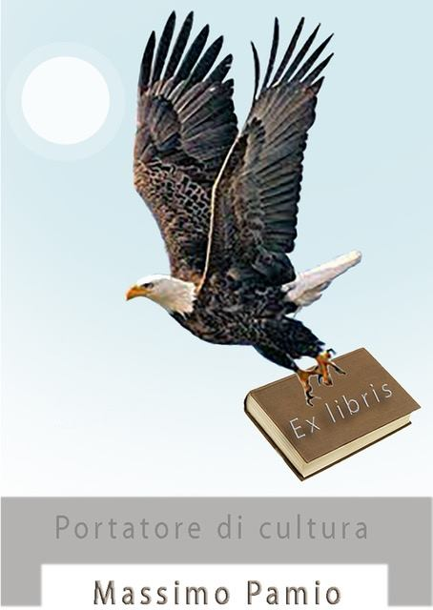
Vinicio Verzieri’s Ex libris
CURRICULUM VITAE MASSIMO PAMIO
Massimo Pamio, essayist and writer, is director of the Love Letter Museum©®, a unique museum in the world, and editorial director of Edizioni Mondo Nuovo.
Knight of the Order "Al Merito della Repubblica Italiana" for cultural merit.
He has worked in publishing since 1978 and has directed Editions Noubs for 20 years. He directed the video Poets, cities the first video shot in Abruzzo comparing a poet with his own city, indexed by IMDb, the world's film and audiovisual database. He has published numerous works in volume on essay: Arrivabene/Pamio (2023); Bisandola/Pamio (2022); Cetera/Pamio (2021); To feel him to feel. What is thinking (2020), Padovani/Pamio (2020), Sensitive to Forms. What is Art” (Mimesis, 2019); in the prestigious series directed by Prof. Pierre Della Vigna (Univ. Insubria) and in the scientific committee Jean Jacques Wunenburger (Univ. Lyon), one of the greatest living art historians. (2019).
Poetry: In the name of the rose (1987), in the confuse apartment of days(1999), Bucanotte (2008), Luceversa (2009), Amormorio (2010); Anonimie (2023), Egolari (2024). Monographs on writers: Domenico Cara, (1987), Vito Moretti (1991), Antonio Spagnuolo, (1991), Cesare Ruffato, (1999); Sirens, by Pierluca Cetera (2023), Writings on D’Annunzio by Ramiro Ortiz (2024), with Riccardo La Rovere, Who was Gabriele D’Annunzio (2024) and Who was Francesco Paolo Michetti. (2024), with Monica Ferri, Gabriele d'Annunzio's finest poems and more… with an appendix of D'Annunzio mottos, and pages on art (2023), Rome and Sant’Arsenio by Elio Pecora (2021), Lanciano by Giuseppe Rosato (2019), Saramago: a Nobel prize for Portugall (with Igino Creati, 1999).He has written thousands of reviews and reports of art exhibitions, books, films, plays, and cultural events in national (Tam Tam, Dismisura, The Trojan Horse, Inverse, Hortus, Today and Tomorrow, Meeting Point, Literary Abruzzo, Traces, The Messenger, Time, etc.) and international (Don Quichotte, Spain, 2 plus 2, France) magazines. He edited the International Magazine Pandere, on which he selected works by the artists Bertina Lopes, a Mozambican artist who recently passed away, one of the most interesting African artists, the Arab painter Zuad Dalloul, the Japanese Kengiro Azuma, and Vittorio Bruni, Adriano Pompa, Vincenzo Sorrentino, Patricia Nichols, Zach Manzi, Sandro Visca, Ennio Di Vincenzo, Paolo Gioli, Ezio Gribaudo. He also collaborates as an editor with numerous magazines: Benandanti, Auralcrave, Frequenze Poetiche, Pagina 21, Diacritica. On Auralcrave he publishes texts enriched with illustrations by well-known artists including two internationally renowned artists, such as Englishman Ken Currie and Mexican Arturo Morin, who were grateful for their inclusion, soon to be Gottfried Helnweyn. Promoted and organized the Corriera della Poesia, a finalist for the Telecom Bellezza prize, awarded by Umberto Eco in Milan. He organizes the Love Letter Award in Torrevecchia Teatina. He conceived "Casa d'Autore" in Capestrano (Aquila), a house- museum where photos, texts, paintings by authors are on display, which aims to offer a space for serenity and reflection, a nest for thought and the heart: all artists or scientists who want to use it, can do so, hosted free of charge in exchange for a gift (a poem, a story, a painting, a page of their research) that will then be kept in the house.

